ARtisan
Final Year Project Proposal
Session 2023-2027

A project submitted in partial fulfillment of the
COMSATS University Degree
of
BS in Computer Science / Software Engineering (CUI)



Department of Computer Science
COMSATS University Islamabad, Lahore Campus

Project Registration
Project ID (for office use)
Type of project |  |  | [✔] Traditional [ ] Industrial [ ] Continuing
Nature of project |  |  | [✔] Development [ ] Research & Development
Sustainable Development Goals(SDGs) |  |  | [ ] Good Health and Well-Being [ ] Quality Education  [✔] Industry, Innovation, and Infrastructure [ ] Gender Equality  [ ] Decent Work and Economic Growth [ ] Climate Action
Area of specialization |  |  | [✔] Artificial Intelligence (AI) [ ] Blockchain [ ] Cybersecurity  [ ] Data Science and Analytics [ ] Game Development  [ ] Internet of Things (IoT) [✔] Natural Language Processing (NLP)  [ ] Mobile App Development [✔] Web Development
Project Group Members
Sr.# | Reg. # | Student Name |  | Email ID | Phone # | Signature
(i) | SP23-BSE-172 | Warda Saeed |  | sp23-bse-172@cuilahore.edu.pk | 03215927607
(ii) | SP23-BSE-145 | Saim Jamil |  | sp23-bse-145@cuilahore.edu.pk | 03008143667
(iii) | SP23-BSE-152 | Syed Muaarij Nadeem |  | sp23-bse-152@cuilahore.edu.pk | 03231021387
Declaration: FYP group members have cleared all prerequisite courses For FYP-I as per their degree requirements.
For BS(Computer Science) and BS(Software Engineering)
(CSC241 Object Oriented Programming, CSC291 Software Engineering Concepts, CSC270 Database Systems, HUM102 Report Writing Skills)
For BS(Artficial Intelligence)
(CSC291 Software Engineering Concepts, HUM102 Report Writing Skills)
Plagiarism Free Certificate
This is to certify that I am Warda Saeed S/D/o Saeed Ahmad, group leader of FYP under registration no CUI /SP23-BSE-172/LHR at the Computer Science Department, COMSATS University Islamabad, Lahore Campus. I declare that my FYP proposal is checked by my supervisor and the similarity index is ________% that is less than 20%, an acceptable limit by HEC. The report is attached herewith as Appendix A.
Date: 16-09-2025 Name of Group Leader: Warda Saeed Signature: __________
Name of Supervisor: __________________ Co-Supervisor (if any):_________________
Designation: _____________________ Designation: _____________________
Signature: _____________________ Signature: _____________________
ABSTRACT
E-commerce has grounded deep into society and led it towards online shopping to great extent. The increase in online shopping offers great convenience in shopping but it has given rise to certain important challenges, mainly in product visualization. Customers struggle with envisioning products in 3D space, especially in domains such as home furnishing and decor items. Because customers are greatly concerned about how these items will be adjusted in their personal space. This psychological disengagement or, which we term the “spatial imagination deficit” frequently leads to uncertainty in purchases thus increasing the return rate of products. Our project, “ARtisan”, resolves this issue by proposing a modernistic web-based platform that emphasizes the power of Generative Artificial Intelligence in combination with Web-based Augmented Reality (WebAR). Users will gain exceptional capability to articulate desired product features via text prompts, generating unique 3D models. These extraordinary creations can be then immediately visualized within the customers’ real-world space. These models are easily accessible through a standard or even a low-end web browser on a mobile device. By combining AI-driven personalization with AR technology, ARtisan focuses to enhance confidence, minimize uncertainty and decline the graph product returns. The expected final form might provide a more modernistic, interactive and reliable online shopping experience that not only enhances customer satisfaction rate but also revolutionizes the way online retail platforms showcase products. Moreover, the reduction in product returns will engage and encourage the sellers to contribute more to e-commerce, leading to economic growth.

Introduction
The trend of online shopping has increased with increasing advancements in E-commerce. It modifies the way the customers interact with products and make purchasing decisions. With the advancements in internet access, mobile technology and digital payment, online shopping has emerged as the first choice of countless customers worldwide. Customers prefer to browse online catalogs and buy products and save time instead of visiting showrooms physically. This shift is significantly visible in sectors such as home furnishing and decor or other home decorations. Despite convenience, however, this changing behavior raises a significant challenge: customers cannot physically interact with or visualize the product in their personal environment before purchase. This creates a gap between reality and expectation that creates confusion in the customer’s mind and leads to dissatisfaction, hesitation in decision making and an alarming rate of product returns.
This gap requires great attention when things come to aesthetics, dimensions, and spatial placement. Such information is insufficient for accurately determining how the product will look-like, fit and feel in customers’ environment. Furniture and décor items significantly require 3D models. This problem, commonly referred to as the “spatial imagination deficit”, prevents customers from finalizing the products with confidence, Studies in psychology especially customer psychology emphasizes that when imagination and reality do not align, it undermines trust in online shopping platforms and reduces customer loyalty. It not only affects the customers but also creates an environment of dissatisfaction and financial burden on sellers, as product returns significantly increase logistical costs and inventory management issues.
Several solutions have been proposed regarding this problem, but they, somehow, fall short in key aspects. Traditional approaches have limited scope, unable to cover the gap of imaginative and real-world space. Some offer only static images and the other mobile AR apps require top-notch hardware and high downloads, making these apps approximately inaccessible to middle class people. Some have fixed inventories offering no customization. Some restrict creativity and have limited user control. Thus, despite existing efforts, there is still no comprehensive and accessible solution that effectively addresses both the visualization and personalization aspects of online shopping.
To overcome these shortcomings, we offer the innovative web-based AR platform “ARtisan”. Our project, ARtisan, covers this gap by integrating Generative AI with Web-based Augmented Reality. Unlike existing AR applications, ARtisan is designed to be accessible directly through standard web browsers. It allows users to communicate with AI in natural language without requiring any high skills to describe the desired designs. Generative AI helps users visualize the unique 3D models, evaluate scale and let them know how the product fits in their real-world space, according to their given prompts. ARtisan offers live rendering and eliminates the need for high memory consuming apps. By combining AI-driven creativity with accessibility of WebAR, ARtisan provides a seamless, user-friendly and highly interactive shopping experience.

ARtisan aims to bring a revolutionary change in the field of product visualization that might lead to reduced purchase uncertainty in online purchasing, and an increasing satisfaction rate of customers. The major tasks performed in project would include a reliable and high-performance AI model capable of transforming simple text prompts into interactive, customizable and easy-to-use 3D models, integration WebAR technologies allowing users enjoying great experience of seamless live rendering instantly with aid of a lightweight, accessible and user-friendly web interface that provides rendering without any performance limitations.
To meet success criteria, the project will focus on evaluating the factors that indicate decreased number of returned products, increase in satisfaction rate and positive feedback from customer side and availability and accessibility over several devices. The statistics of these achievements will be demonstrated through system prototypes, user testing and comparison analysis between ARtisan and other existing solutions.
Ultimately, ARtisan focuses on improvements and a revolutionary change in online shopping experience by bridging the gap between imagination and reality. The expected outcomes include a substantial reduction in purchase uncertainty, improved decision making, enhanced customer satisfaction and lowered product return rates. By achieving this, the project not only benefits consumers by providing greater creativity and a satisfactory environment but also encourages the sellers to invest more by reducing the logistical costs of the returned products. By merging the most emerging, advanced and high-end technologies in AI and AR, ARtisan aims to redefine and transform the way e-commerce platforms approach product visualization and deliver long-term value to the digital marketplace.

Related work

Meshy AI
Meshy AI^{[1]} is a web tool that turns text or images into 3D models, mainly used for VR, games, and digital design. It shows how AI can simplify 3D creation.
- Similarity: Both Meshy and ARtisan let users create 3D models from text prompts.
- Difference: Meshy stops at generation, ARtisan goes further by letting users place those models in real-world AR scenes.

Tripo AI
Tripo AI^{[2]} focuses on speed, letting users create 3D models from text, images, or doodles in seconds. It’s popular among creators who need quick assets.
- Similarity: Like ARtisan, it offers fast and flexible text-to-3D generation.
- Difference: Tripo doesn’t support AR placement, while ARtisan combines generation with in-browser AR visualization.

Sloyd AI
Sloyd AI^{[3]} is a browser-based generator that mixes text prompts with editable templates to produce ready-to-use 3D models. It’s known for its lightweight and optimized models.
- Similarity: Both Sloyd and ARtisan focus on making 3D modeling simple and web-friendly.
- Difference: Sloyd relies on templates and parametric changes, while ARtisan generates models entirely from scratch and places them in real-world AR.

CGTrader ARsenal
Arsenal^{[4]} is a service for retailers that allows shoppers to preview products in AR through online stores. It integrates with e-commerce platforms like Shopify.
- Similarity: Like ARtisan, it improves online shopping by showing products in real spaces.
- Difference: ARsenal only works with pre-existing 3D models, while ARtisan creates custom 3D designs from user prompts.

Sketchfab
Sketchfab^{[5]} lets users upload, share, and interact with 3D models directly in browsers using WebGL and WebXR. Some models can even be previewed in AR.
- Similarity: Both provide web-based interactive 3D/AR visualization without app downloads.
- Difference: Sketchfab depends on pre-uploaded models, while ARtisan generates unique models on demand using AI.

NeurIPS
J. Wu, C. Zhang, X. Zhang, Z. Zhang, W. T. Freeman, and J. B. Tenenbaum, “Learning a probabilistic latent space of object shapes via 3D generative-adversarial modeling,” in Advances in Neural Information Processing Systems (NeurIPS)^{[6]}, vol. 29, pp. 82–90, 2016.
This work pioneered probabilistic latent space learning for generating 3D object shapes. It provided a solid foundation for text-to-3D pipelines but was primarily research-oriented and lacked real-time usability.
- Similarity: Artisan is not research-oriented, it is mostly development oriented.
- Difference: Unlike this offline framework, ARtisan offers on-demand, real-time model generation with direct in-browser AR visualization, making it practical for e-commerce use.

Proposed Methodology and Architecture

Methodology
The employed methodology for the envisioned web application will be an Agile-based methodology. With its iterative approach planning, development, continuous feedback & improvement will be possible which is beneficial for such a project with AR and AI technologies. The project’s progress will be assessed after each iteration which comprises of,
- Requirement elicitation.
- System design.
- Prototyping of UI for easy frontend development.
- Development of modules.
- Integration of modules with source code.
- Testing of implemented functionalities.
- Feedback from supervisor and group members for improvement.
This approach promises a working software with agreed upon and reviewed functionalities lowering the risks of re-engineering and refactoring whole code.

Architecture
Layered architecture will be an efficient approach for the proposed application. It will focus on separation of concerns and modularity which will help in development of such an application within a team. It also aligns with the iterative methodology of the project. The proposed system comprises of four main layers,

Presentation Layer:
It provides User Interface and AR visualization using WebXR and Three.js.

Application Layer:
It manages API calls, user requests and core logics of the application.

Services Layer:
It includes Gen AI implementation and AR modules for object rendering.

Data Layer:
It handles user data (credentials and user design assets) and pre-made 3D assets.
Along with modularity and separation of concerns, the layered architecture makes it easy to integrate new modules like AI and AR integration, allowing it to be easily scalable and maintainable.

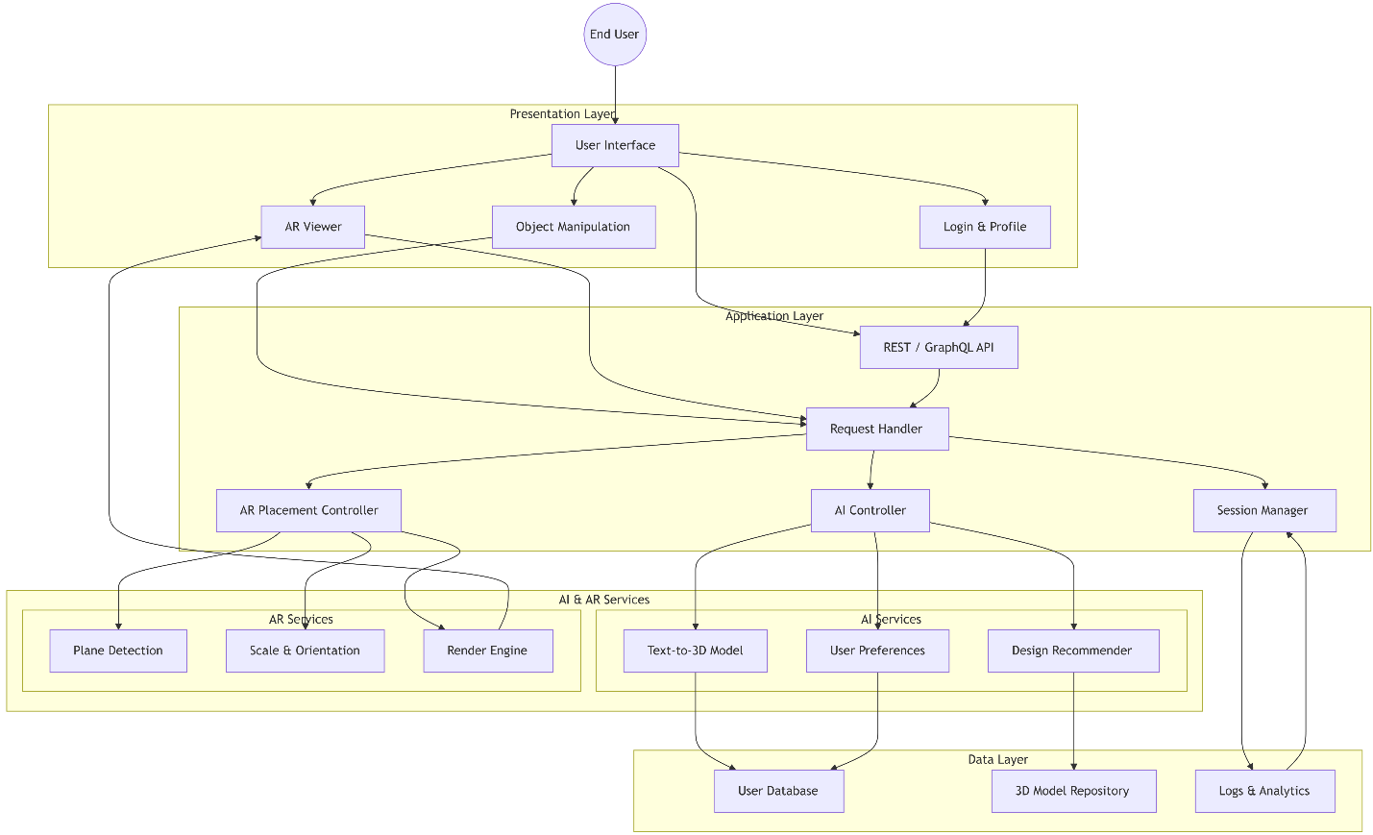
Figure 3.1: Layered Architecture overview of whole system

Success Criterion
The project will be considered as successful if the outcoming web app aligns with all its objectives including the following:
- Functional Accuracy
- 3D objects generation or using pre-made templates and place them in AR. Scale and resize the objects in real-time.
- AI recommendation for generation and placement of objects.
- User Experience
- The overall web app will be user-friendly in terms of navigation, AR visualization and generation via AI.
- Objects in an AR scene can be manipulated smoothly and have a clear visualization.
- Cross Platform Access
- This web app will run successfully on major browsers like Chrome, Edge & Brave etc. providing all functionalities.
- Web app will adapt according to different screen sizes (Desktop, mobile, tablet etc.).
- Error Handling
- This web application will handle errors like invalid inputs, unsupported file formats with proper error messages.
The success of the project will be determined by the success of the product without compromising the mentioned baseline functionalities, completion of project within the defined timeline and proper documentation of the system.

Team Roles and Responsibilities
Team Member | Activity | Tentative Date
Syed Muaarij Nadeem | Requirement gathering, AR/3D module setup, object placement | Jan–Feb 2026
 | Object manipulation (move, rotate, scale) | Mar 2026
 | UI/UX development for Customer Mode | Apr 2026
Warda Saeed | Backend development with Node.js and database setup | Feb–Apr 2026
 | Integration with Text-to-3D APIs | May 2026
 | Progressive rendering pipeline implementation | Jun 2026
Saim Jamil | Designer Mode features (project saving, scene management) | Jul–Aug 2026
 | Final testing of features | Sep 2026
 | Documentation, and presentation prep | Oct–Dec 2026

Gantt Chart
Task / Phase | Jan | Feb | Mar | Apr | May | Jun | Jul | Aug | Sep | Oct | Nov | Dec
Requirement Gathering & Research
Literature Review & Related Work
System Design (UI/UX + Architecture)
Frontend Development (React + AR)
Backend Development (API + DB + AI)
AI & AR Module Implementation
Integration & Middleware Setup
Testing & Debugging
Refinement & Performance Tuning
Documentation & Report Writing
Final Presentation & Submission

Tools and Technologies
The development of ARtisan will employ a modern and scalable technology stack that supports Generative AI, Web-based Augmented Reality, and 3D rendering. The following tools and technologies will be used,

Presentation Layer:
The frontend will be developed using HTML, CSS, JAVASCRIPT with React.js for building responsive components, and Three.js with WebXR for rendering AR-based 3D models.

Application Layer:
The backend will utilize Node.js with Express.js for API handling and communication.

Services Layer
Generative AI functionalities will be supported through python and open source AI models.

Data Layer
The MongoDB Community Edition will manage user data, while firebase will be used for storing 3D assets.

Deployment and Hosting
Deployment will be handled on Netlify for frontend and Render for Backend.

Project Management and Testing
For project management and testing GitHub, Trello/Jira, Postman will be employed

References

[1] | Meshy, “Meshy AI - #1 AI 3D Model Generator,” Meshy AI - Create 3D Models From Text and Images With AI, Jan. 15, 2024. https://www.meshy.ai/
[2] | “Tripo AI - Create Your First 3D Model with Text and Image in Seconds.” https://www.tripo3d.ai/
[3] | “AI 3D Model Generator - Create with Text to 3D.” https://www.sloyd.ai/
[4] | CGTrader, “CGTRader - 3D Model Store,” CGTrader. https://www.cgtrader.com/
[5] | Sketchfab, “Sketchfab - The best 3D viewer on the web,” Sketchfab. https://sketchfab.com/
[6] | J. Wu, C. Zhang, X. Zhang, Z. Zhang, W. T. Freeman, and J. B. Tenenbaum, “Learning a probabilistic latent space of object shapes via 3D generative-adversarial modeling,” in Advances in Neural Information Processing Systems (NeurIPS), vol. 29, pp. 82–90, 2016.

